### **E-commerce Platform Search Function**

### **Understanding Asymptotic Notation**

#### **Big O Notation**

Big O notation is a mathematical representation used to describe the efficiency of an algorithm as the size of the input grows. It expresses the upper bound of an algorithm's running time, helping developers understand the worst-case performance in terms of time or space.

For example:

* **O(1)** – Constant time, regardless of input size.
* **O(n)** – Linear time; performance scales directly with input size.
* **O(log n)** – Logarithmic time; performance increases slowly even as input size grows significantly.
* **O(n²)** – Quadratic time; performance degrades rapidly with input size increase.

Understanding Big O helps in choosing the right algorithm based on expected input sizes and required performance.

#### **Best, Average, and Worst-Case Scenarios**

Each search algorithm can behave differently depending on the input data and what is being searched.

* **Best Case:** The target is found immediately (e.g., at the beginning of a list).
* **Average Case:** The target is found somewhere in the middle or after several comparisons.
* **Worst Case:** The target is not found or is located at the end of the dataset.

Analyzing all three scenarios helps assess the robustness of a search algorithm under different conditions.

### **Analysis**

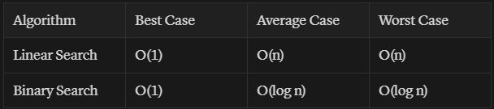

* **Linear Search** is simple and effective for small datasets but becomes inefficient as the size of the dataset grows.
* **Binary Search** is highly efficient for large, sorted datasets. However, the additional overhead of keeping data sorted must be considered.

#### **Preference**

For an e-commerce platform with potentially thousands or millions of products, **binary search** is more suitable due to its logarithmic time complexity. To ensure performance, maintaining a sorted product list or using data structures such as binary search trees or hash maps may be necessary. If real-time sorting or complex queries are required, consider more advanced search techniques or integrating a search engine (like Elasticsearch).